**North Carolina Migrant Education Program**

**New Enrollment Report Steps**

**NEW ENROLLMENT REPORTS**

New enrollment reports in PowerSchool provides information of students enrolled in any school district between a selected date. This report can be used for Identification & Recruitment efforts. To run the report, you need a PowerSchool account. Once on the main page in PowerSchool, follow these instructions.

1. Type this command in the search bar of the LEA in PowerSchool:

Entrydate>01/15/2020;entrydate<03/16/2020 (sample). Hit enter. This will bring all the students enrolled in the school district between the dates selected.

1. Under “Current Student Selection” and on the left-hand corner, you will see either “Select Function”, “Special Functions”, or “Quick Reports” depending on the type of access you have. 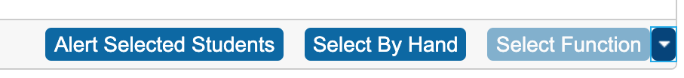

Click the drop down arrow next to either of the options mentioned above, and click on “Quick Export”. This opens a window to create fields for the list.

1. Enter the following commands in the text box, leaving no spaces anywhere, not even at the end of the last word:

* Last_name
* First_name
* Student_number
* Enrollment_date
* Grade_level
* Entrydate
* Districtentrydate
* Ethnicity
* Street
* City
* Home_phone
* S_NC_STUDENTDEMO.PREVIOUS_STATE
* Father_name
* StudentCoreFields.father_employer
* Mother_name
* StudentCoreFields.mother_employer

1. Click Submit. This will download the report of new enrollments between the dates selected in a Text Edit format or on the Notepad Report. On either of these formats, click Edit, Select All, Edit, & Copy.
2. Open an Excel sheet and click on A1 cell. Click Paste Special.

These reports are uploaded into Share Points in folders for the Regional Recruiters.