Targeted Assistance Schools (TAS) Data Collection

How to Add Students and Submit Data in PowerSchool

**What is the TAS Data Collection?**

Targeted Assistance Schools (TAS) are schools that provide supplemental services to a select group of students who are identified as failing or at risk of failing to meet state academic standards. The goal of these schools is to improve teaching and learning so that students can meet these standards.

When entering student population and poverty data for a school in Eligible Schools Summary Report (ESSR), the Eligibility Program Model for a school(s) can be *TAS-TAS* or *SW-TAS*. Once a school(s) is tagged as either of these, the LEA will have to tag students as TAS within *TAS-TAS* or *SW-TAS* school(s).

Please note that these are student level data, and as such, are FERPA-protected. If you need to convey student names, please do do in an encrypted manner, such as a password-protected Excel spreadsheet.

1. Log into PowerSchool. On the Start Page menu (left side of screen), you should see a section for **Federal**, then under **Title I**, you will see ESSR. Click on ESSR.

1. View ESSR and see which school(s) have *TAS-TAS* or *SW-TAS* as its Eligibility Program Model in that column. In the following example, one school, Isaac Dickson Elementary School, is indicated with an Eligibility Program Model of *TAS-TAS*.

1. Change ‘PSU Office’ using the pulldown to choose the school noted as *SW-TAS* or *TAS-TAS* in ESSR. In this example, the only school with *SW-TAS* or *TAS-TAS* is Isaac Dickson Elementary.

1. Select the school, then click on TAS in the menu on the left side.

1. Once in the TAS screen for the school, click on Start Page to select the students. You might see a list of TAS students from last year, as they are pushed forward into the next school year, provided they are still on the roster for that school. You will have an opportunity to remove these students if they are no longer receiving TAS services.

1. Using the pulldown, there are multiple paramters for selecting students to add to the TAS data collection, as shown below. Choose ‘All’, followed by entering a letter in the field to the right of the pulldown (marked in yellow), in this case ‘A’, which will render a list of students whose last name starts with an ‘A’. Entering a ‘3’ will render a list of 3rd graders. Alternatively, you can choose one of the other more specific parameters.

The field in yellow indicates your search criteria. As seen in the pulldown, you can search by Last Name, First Name, Student Number, State Student Number, Grade Level and Date of Birth.

1. These students can be added one-by-one by clicking on the + sign. Once a student is selected via this means, the  turns to a , and a table appears for the selected students. You can scroll down through the ‘A’s and select the students.

1. When you click on the  button, a list of the students previously selected by Last Name starting with an ‘A’ will be rendered. You can uncheck students not in the TAS program if you’ve made an error in their selection.

If you uncheck any students, you must click on the  button. In these screenshots, you can see that the list has been reduced to 4.

1. When you are ready to ‘Tag Students as TAS’ in a batch mode fashion, click on pulldown menu to right of , scroll to the bottom of the Function list, to choose **Federal** – Tag as TAS.

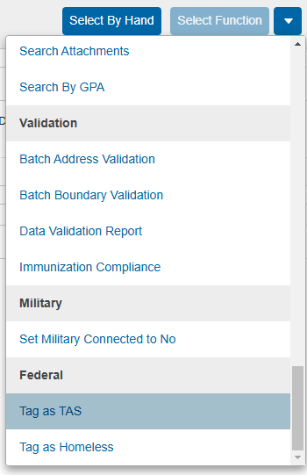

Once selected, the function button becomes .

1. Once button is clicked…

+

1. After clicking on 

You do not need to edit any of the parameters, as NCDPI will collect TAS student counts and not their services received or eligible for; these have all been entered with the default values.

If you need to add more students, go back to Step 6. Do not Approve your data until you are satisfied you have captured all TAS students at your PSU.

1. If you are ready to Approve the TAS student data, return to PSU Office, then click on the TAS link on the left. Please read the instructions in the Approval box.

If you’re satisfied your data is complete, click on the button. You will have to click on the button again, as shown in the next screenshot.

Clicking on will render the screenshot with aggregate data.

**NOTES**

1. If a student that was served as TAS has transferred to another school within the district, the can be used.

1. If you’ve mistakenly Approved the data and need it unsubmitted, please send an email to [james.popp@dpi.nc.gov](mailto:james.popp@dpi.nc.gov), with your PSU number, and he will convey your request to the appropriate personnel.