Appendix 6-A: Test Character Curves, Information Functions and Conditional Standard Error of Measurement

Test Characteristic Curves (TCCs)

- Grade 3 TCCs Math 2018-19 Operational Forms
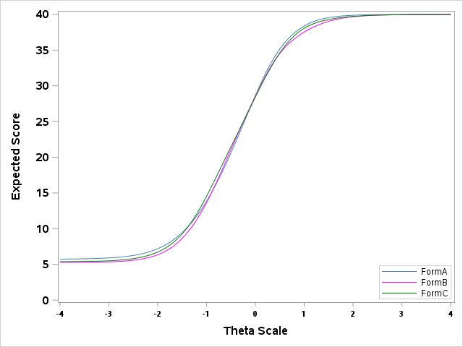

- Grade 4 TCCs Math 2018-19 Operational Forms
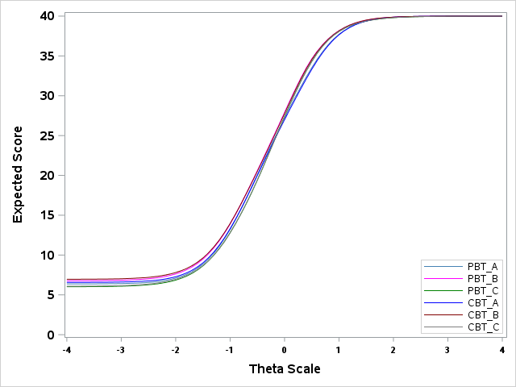
- Grade 5 TCCs Math 2018-19 Operational Forms
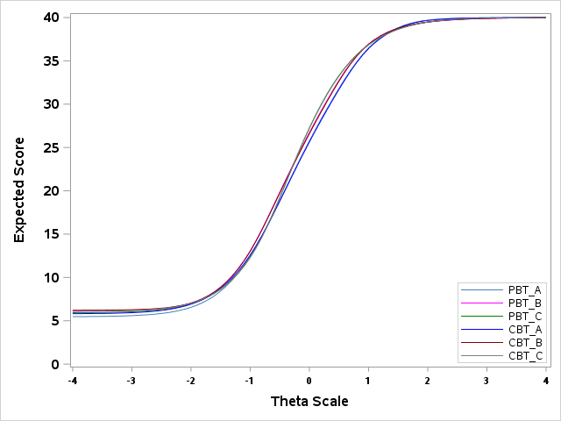

- Grade 6 TCCs Math 2018-19 Operational Forms
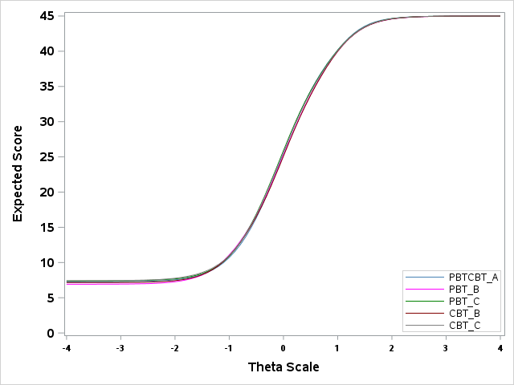
- Grade 7 TCCs Math 2018-19 Operational Forms
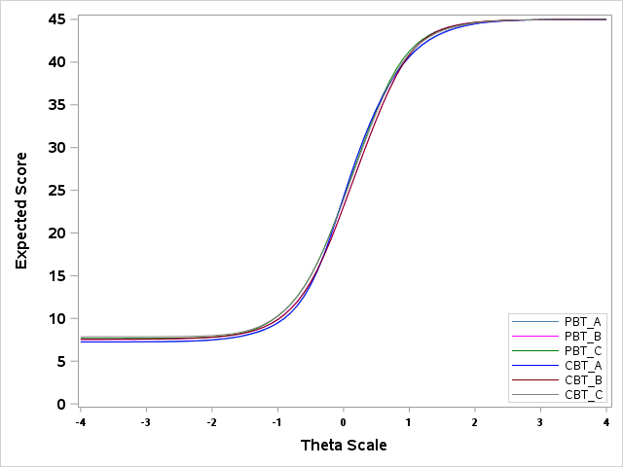

- Grade 8 TCCs Math 2018-19 Operational Forms
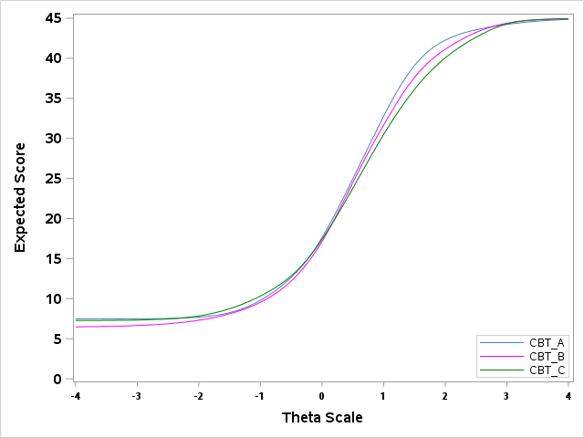
- NC Math 1 TCCs 2018-19 Operational Forms
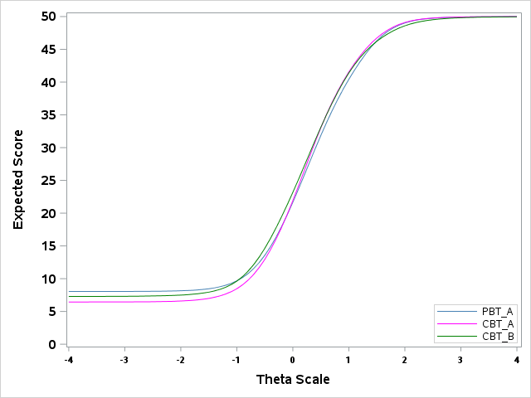

- NC Math 3 TCCs 2018-19 Operational Forms
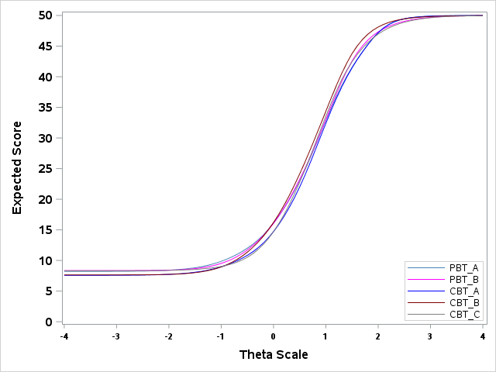
Test Information Functions (TIF) and Conditional Standard Error of Measurements (CSEM)

- Math Grade 3 TIFs and CSEM 2018-19 Operational Forms
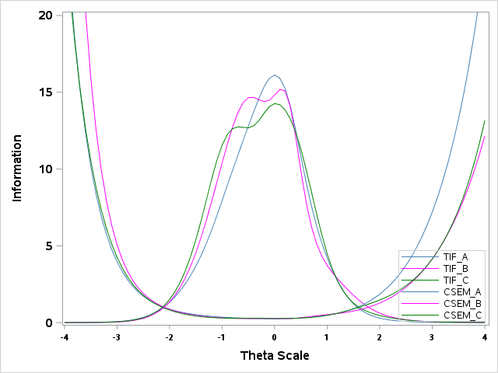

- Math Grade 4 TIFs and CSEM 2018-19 Operational Forms
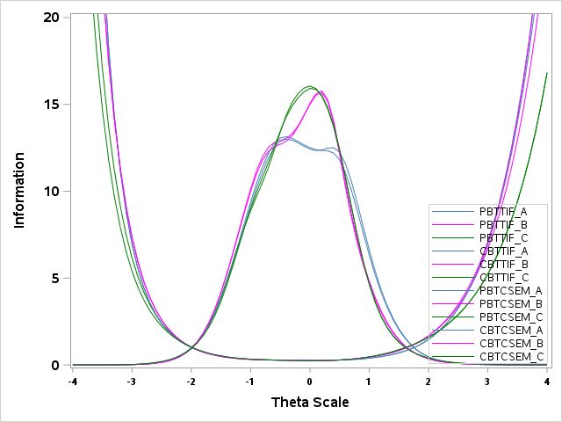
- Math Grade 5 TIFs and CSEM 2018-19 Operational Forms
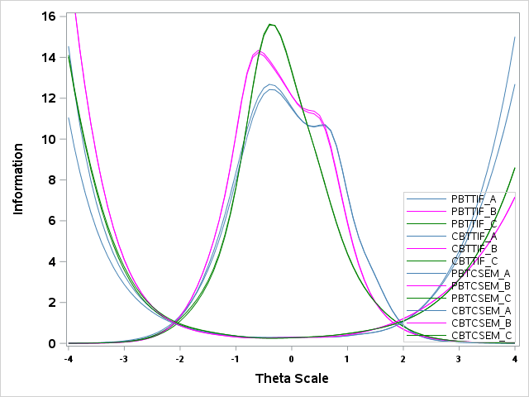

- Math Grade 6 TIFs and CSEM 2018-19 Operational Forms
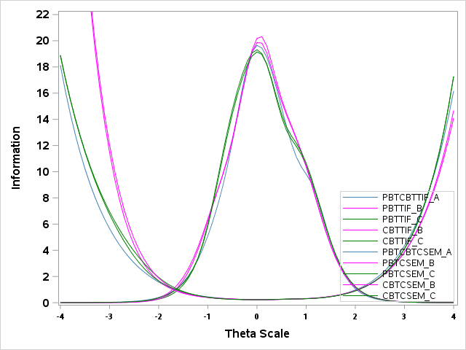
- Math Grade 7 TIFs and CSEM 2018-19 Operational Forms
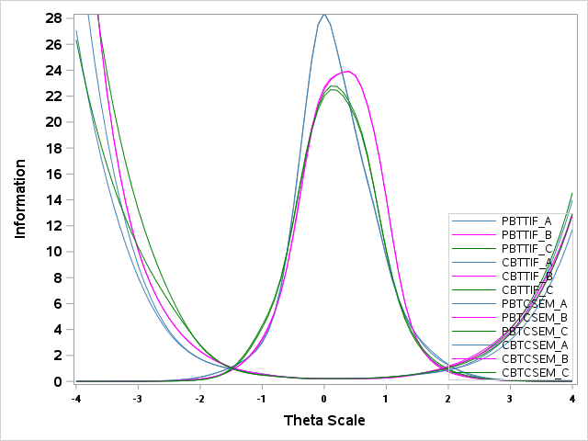

- Math Grade 8 TIFs and CSEM 2018-19 Operational Forms
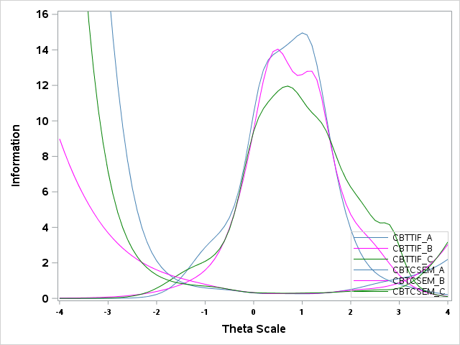
- NC Math 1 TIFs and CSEM 2018-19 Operational Forms
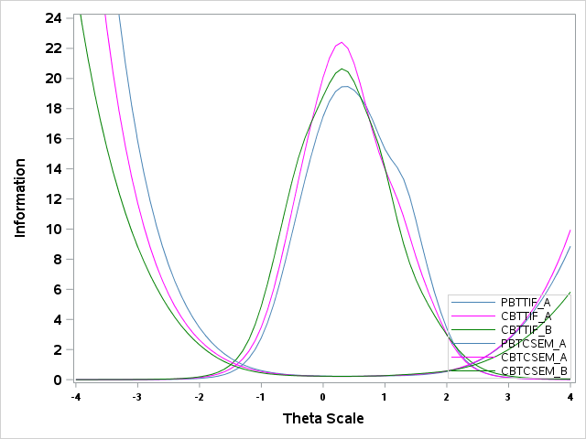

- NC Math 3 TIFs and CSEM 2018-19 Operational Forms
