Directions for Registering for and Accessing Assessment Data from CEDARS

Step 1: Registering for Access to CEDARS

If you already have registered access to CEDARS continue to Step 2.

Registering for the CEDARS Data Warehouse is a three-step process.
- Ensure you have an NCID. (K-12 Public and Charter School employees are registered by the Charter/LEA NCID Administrator)
- Apply for an account using the CEDARS Data Warehouse Registration System
- Log into the reporting interface (OBIEE) after account confirmation

Each LEA and charter must have at least one staff member who has been designated the Security Officer in the CEDARS Data Warehouse. This staff member will be notified via email each time a user requests access and may then functionally approve or deny the registration request in the Registration system. If there is no Security Officer at the local level the account will not be approved.

Step 2: Accessing Assessment Data from CEDARS

Directions:

- Log in to CEDARS Data Warehouse
- Select- Dashboard Reports
- Select- Table of Contents
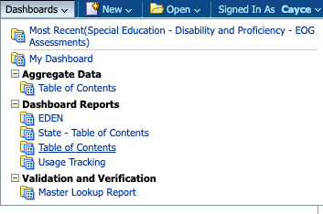
- Select- Special Education from the Program Options
- Select- EOG Proficiency by Disability Report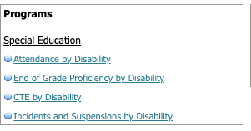
- Select- the Reporting Year (Select- 2018-19) (Note: no data for 19/20 due to COVID-19 and 20/21 has not been posted) from the drop down menu
- Select- LEA (depending on access level) from the drop down menu
- Click- Apply
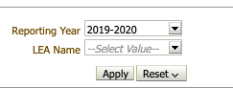
- The Proficiency by Disability and Assessment table will populate on the screen
- In the Proficiency by Disability table on the Right side of the screen- In the second column click on the LEA Name hyperlink below the heading LEA Name (second column). This will expand the table to show the data for each school within the LEA and a new column named School Name should be added.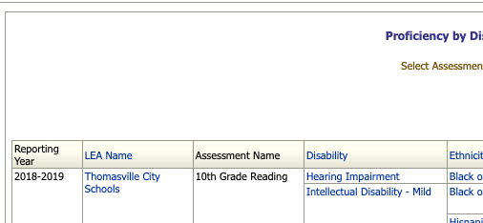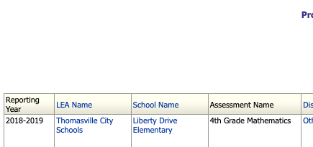
- Scroll to the bottom.
- Click Export
- Select Data
- Select Tab Delimited
